Csci 41: Introduction to Data Structures
Lab Exercise 7
Lab Instructor: Supreet Singh Palne
March 11, 2021

Objectives:
- Algorithm Analysis

Algorithm Analysis (Either answer it on a paper or in a Word doc):
Exercise Summary: Count the number of comparisons in the following code snippets. Then generalize it and represent your count by using N, where N=16. The following three formula may help you for analysis.
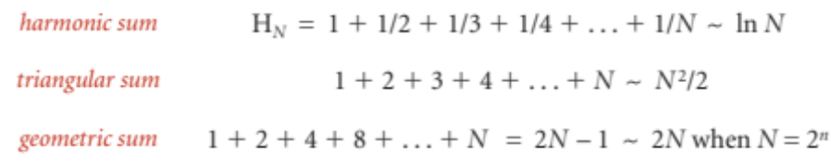

(a)
int sum = 16; //N=16
while (sum >= 1)
{
sum--;
cout<<sum<<endl;
}

(b)
int sum = 1; //N=16
while (sum <= 16)
{
sum=sum*2;
cout<<sum<<endl;
}

(c)
int sum = 0; //N=16
for (int i = 0; i < 16; i++){
for(int j = 0; j < 16; j++) {
sum++; }}

(d)
int sum = 0; //N=16
for (int i = 0; i < 16; i++){
for(int j = i; j < 16; j++) {
sum++; }}

(e)
int sum = 0; //N=16
for (int i = 1; i < 16; i +=2){
for (int j = 0; j < i; j++) {
sum++; }}

(f)
int sum = 0; //N=16
for (int i = 1 i < 16; i *= 2)
for (int j = 0; j < 16; j++)
sum++;

(g)
int sum = 0; //N=16
for (int i = 1 i < 16; i *= 2)
for (int j = 0; j < i; j++)
sum++;
Use geometric sum formula**

SHOW ME your work and explain it to TA.

